|  |  |
| --- | --- |
|  | **BAHRIA UNIVERSITY,**  **(Karachi Campus)**  *Department of Software Engineering*  **ASSIGNMENT 02 – Fall 2023** |

COURSE TITLE: **Computer Communication & Networks** COURSE CODE: **CEN-223**

Class: **BSE - 5** Shift: **Morning**

Course Instructor: **Dr. Muhammad Hussain** Date: **Oct 20, 2023**

Due Date: **Oct 30, 2023** Marks: **5.0 Marks**

Name: **Muhammad Shoaib Akhter Qadri** Enrollment No: **02-131212-009**

By analyzing the concepts and working phenomena find the solution of scenarios given below:

CLO 4

**Q.1 Assume that a voice channel occupies a bandwidth of 4 kHz. We need to combine three voice channels into a link kHz. We need to combine three voice channels into a link with a bandwidth of 12 kHz, from 20 to 32 kHz. Show the configuration, using the frequency domain. Assume their configuration, using the frequency domain. Assume there are no guard bands. here because the packet size is huge.**

**Solution:**

Voice Channel 1: 20 kHz to 24 kHz

Voice Channel 2: 24 kHz to 28 kHz

Voice Channel 3: 28 kHz to 32 kHz

**Q.2 The Advanced Mobile Phone System (AMPS) uses two bands The first band of 824 to 849 MHz is used for bands. The first band of 824 to 849 MHz is used for sending, and 869 to 894 MHz is used for receiving. Each user has a bandwidth of 30 kHz in each direction Each user has a bandwidth of 30 kHz in each direction. How many people can use their cellular phones simultaneously?**

**Solution:**

**For the sending band (824 MHz to 849 MHz):**

Available bandwidth = (849 MHz - 824 MHz) = 25 MHz = 25,000 kHz

Bandwidth per user = 30 kHz

Number of users in sending band = Available bandwidth / Bandwidth per user

Number of users in sending band = 25,000 kHz / 30 kHz = 833.33 users

**For the receiving band (869 MHz to 894 MHz):**

Available bandwidth = (894 MHz - 869 MHz) = 25 MHz = 25,000 kHz

Bandwidth per user = 30 kHz

Number of users in receiving band = Available bandwidth / Bandwidth per user

Number of users in receiving band = 25,000 kHz / 30 kHz = 833.33 users

The total number of users is 833 in each brand.

**Q.3 Four data channels (digital) each transmitting at 1 Four data channels (digital), each transmitting at 1 Mbps, use a satellite channel of 1 MHz. Design an appropriate configuration using FDM appropriate configuration, using FDM.**

**Solution:**

In Frequency Division Multiplexing (FDM), different data channels are combined into a shared transmission medium by allocating each channel a distinct frequency range within the available bandwidth. In this scenario, we have four digital data channels, each transmitting at 1 Mbps, and a satellite channel with a bandwidth of 1 MHz. To design an appropriate FDM configuration, we need to allocate frequency ranges for each of the four data channels within the 1 MHz satellite channel.

Here's how we can allocate frequency ranges:

1. **Determine the bandwidth for each data channel:**

- Each data channel is transmitting at 1 Mbps, so the bandwidth required for each channel is 1 MHz (1,000 kHz). Since you have four channels, you'll need to accommodate a total bandwidth of 4 MHz (4,000 kHz).

2. **Allocate frequency ranges for each data channel:**

- Divide the available 1 MHz satellite channel into four equal parts, each with a bandwidth of 1 MHz (1,000 kHz). These frequency ranges should not overlap and should be separated by guard bands to prevent interference.

- For simplicity, we can allocate the following frequency ranges:

- Channel 1: 0 kHz to 250 kHz

- Channel 2: 250 kHz to 500 kHz

- Channel 3: 500 kHz to 750 kHz

- Channel 4: 750 kHz to 1,000 kHz

3. Use guard bands:

- To prevent interference between adjacent channels, we can allocate small guard bands between them. For example, we can allocate a guard band of 50 kHz between each pair of channels, ensuring a clear separation between the allocated frequency ranges.

The FDM configuration would look like this:

- Channel 1: 0 kHz to 250 kHz (with a 50 kHz guard band on both sides)

- Channel 2: 250 kHz to 500 kHz (with a 50 kHz guard band on both sides)

- Channel 3: 500 kHz to 750 kHz (with a 50 kHz guard band on both sides)

- Channel 4: 750 kHz to 1,000 kHz (with a 50 kHz guard band on both sides)

This configuration allows us to transmit four digital data channels, each at 1 Mbps, through the 1 MHz satellite channel without interference. The use of guard bands ensures that the frequency ranges do not overlap and that there is sufficient spacing to avoid interference.

**Q.4 Figure shows synchronous TDM with a data stream for each input and one data stream for the output. The unit of data is 1 bit. Find (a) the input bit duration, (b) the output bit duration, (c) the output bit rate, and (d) the output frame rate.**

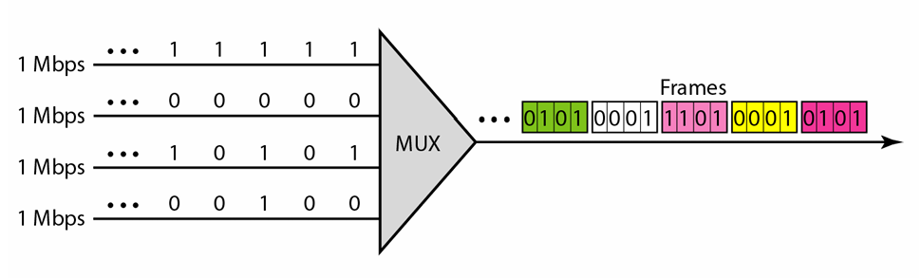

**Solution:**

a. The input bit duration is the inverse of the bit rate: 1/1 Mbps = 1μs.

b. The output bit duration is one-fourth of the input bit duration, or 1/4 us.

c. The output bit rate is the inverse of the output bit duration or 1/4 μs, or 4 Mbps. This can also be deduced from the fact that the output rate is 4 times as fast as any input rate; so the output rate=4 x 1 Mbps =4 Mbps.

d. The frame rate is always the same as any input rate. So the frame rate is 1,000,000 frames per second. Because we are sending 4 bits in each frame, we can verify the result of the previous question by multiplying the frame rate by the number of bits per frame.

**Q.5 Difference between Frequency Hopping Spread Spectrum (FHSS) and Direct Sequence Spread Spectrum Synchronous (DSSS) on the basis of working phenomena.**

**Solution:**

Frequency Hopping Spread Spectrum (FHSS) and Direct Sequence Spread Spectrum (DSSS) are two different techniques used in spread spectrum communication systems. They differ in how they spread the signal across a wide bandwidth. Here's a comparison based on their working phenomena:

1. **FHSS (Frequency Hopping Spread Spectrum):**

* **Working Phenomenon:**
  + FHSS spreads the signal by rapidly switching between different carrier frequencies.
  + The signal is divided into small segments or "chips."
  + A pseudorandom sequence, known as the hopping code or frequency-hopping code, is used to determine the sequence of carrier frequencies.
  + The transmitter and receiver are synchronized to the same hopping sequence.
  + During transmission, the signal rapidly "hops" from one frequency to another, following the predetermined sequence.
  + This hopping process makes it challenging for unauthorized receivers to intercept the signal.
  + **Characteristics:**
  + Provides frequency diversity: FHSS uses a wide range of frequencies for transmission, reducing the impact of interference on a specific frequency.
  + Robust against narrowband interference: Interference on one frequency is typically short-lived due to the rapid hopping, making FHSS resilient against narrowband jammers.
  + Offers some level of security: The hopping sequence must be known to both the transmitter and receiver for successful communication, providing a level of security.

1. **DSSS (Direct Sequence Spread Spectrum):**
   * **Working Phenomenon:**
   * DSSS spreads the signal by modulating the data with a spreading code.
   * A spreading code is a pseudorandom binary sequence with a much higher data rate than the original data.
   * The spreading code is used to modulate the signal by "spreading" it over a wider bandwidth.
   * At the receiver, the spreading code is used to despread the signal, effectively recovering the original data.
   * **Characteristics:**
   * Provides processing gain: DSSS increases the signal power over a wider bandwidth, resulting in improved signal-to-noise ratio.
   * Resilient against narrowband interference: DSSS spreads the interference over the entire bandwidth, making it less effective against the communication signal.
   * Suitable for low data rate applications: DSSS is often used in applications with lower data rates compared to FHSS.

In summary, FHSS spreads the signal by rapidly changing carrier frequencies, while DSSS uses a spreading code to modulate the signal over a wider bandwidth. Both techniques provide resistance to interference and are used in various wireless communication systems. The choice between FHSS and DSSS depends on the specific requirements of the application and the trade-offs between characteristics such as data rate, interference resistance, and security.